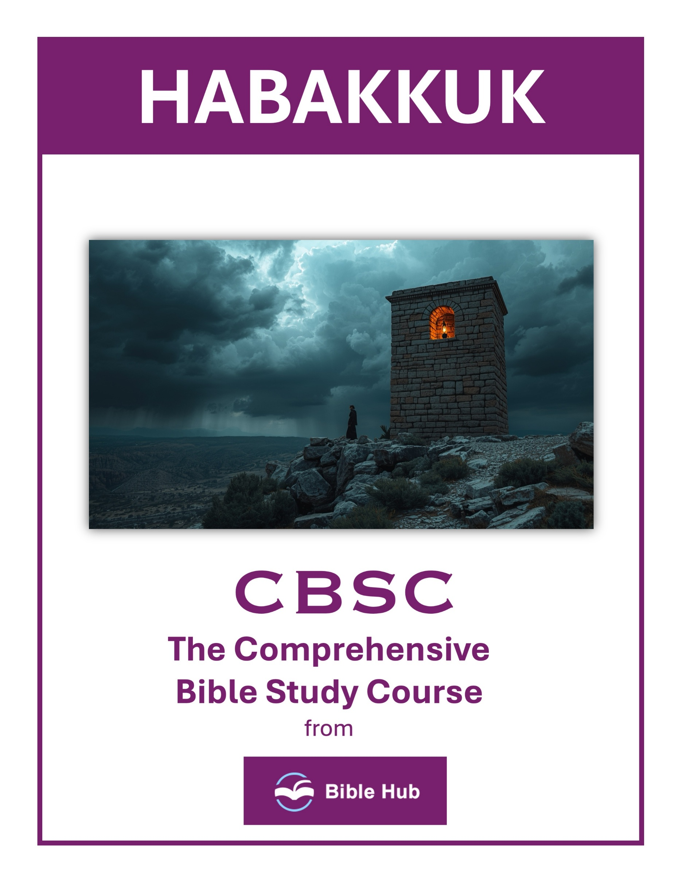

Habakkuk 1 Teaching Points and Bible Study Questions
Embrace Honest Dialogue with God
Habakkuk teaches us the importance of bringing our questions and concerns directly to God. The prophet begins by asking, "How long, O LORD, must I call for help, but You do not listen?" (Habakkuk 1:2). This shows us that God welcomes our honest dialogue and is not afraid of our doubts or questions. Just as Habakkuk did, we can approach God with our deepest concerns, trusting that He hears us.
1. How can you cultivate a habit of honest dialogue with God in your daily life?
2. Why do you think expressing doubts to God can strengthen your faith journey?
3. What would you do differently if you embraced open communication with God about your struggles?
Trust in God's Sovereign Plan
Even when circumstances seem chaotic, Habakkuk reminds us that God is in control. "Look at the nations and observe—be utterly astounded! For I am doing a work in your days that you would never believe even if someone told you" (Habakkuk 1:5). This verse encourages us to trust that God’s plans are beyond our understanding and are always for our ultimate good.
1. How can you trust God's plan when facing situations that seem unjust or confusing?
2. What do you hope to learn about God's sovereignty during challenging times?
3. Why does trusting in God's plan require patience and faith in uncertain circumstances?

Recognize the Reality of Injustice
Habakkuk acknowledges the presence of injustice in the world, asking, "Why do You make me see iniquity, and why do You tolerate wrongdoing?" (Habakkuk 1:3). This recognition is crucial for us today, as it reminds us to be aware of the injustices around us and to seek God’s guidance in addressing them.
1. How can you respond constructively when witnessing injustice in your community today?
2. Why do you think God allows injustice to persist, and how does this affect your faith?
3. What practical steps can you take to advocate for justice in your daily life?
Wait Patiently for God's Timing
Patience is a virtue that Habakkuk exemplifies. Despite his initial impatience, he learns to wait on God’s timing. "For the vision awaits an appointed time; it testifies of the end and will not lie. Though it lingers, wait for it, since it will surely come and will not delay" (Habakkuk 2:3). This teaches us to trust in God’s perfect timing, even when it requires patience.
1. How can you cultivate patience while waiting for God's timing in challenging situations?
2. Why do you think trusting God's timing is difficult, and how can you overcome this struggle?
3. What practical steps can you take to remain hopeful while waiting for God's answers?

Live by Faith
One of the most profound lessons from Habakkuk is the call to live by faith. "But the righteous will live by his faith" (Habakkuk 2:4). This verse is a cornerstone of Christian belief, reminding us that our righteousness comes through faith in God, not through our own efforts.
1. How can you maintain faith when facing situations that seem unjust or unanswered by God?
2. What do you hope to learn about God's character through challenges that test your faith?
3. Why does living by faith require patience and trust in God's timing and plans?
Understand the Consequences of Pride
Habakkuk warns against the dangers of pride, stating, "Indeed, wine betrays the proud man, who is never at rest" (Habakkuk 2:5). Pride leads to restlessness and dissatisfaction, whereas humility before God brings peace and contentment.
1. How can recognizing pride in our lives help us avoid the consequences described in Habakkuk 1?
2. Why do you think pride leads to destructive outcomes, as seen in Habakkuk 1?
3. What steps can you take to address pride and its potential consequences in your daily life?

Acknowledge God's Justice
The book emphasizes that God’s justice will ultimately prevail. "Woe to him who builds a city with bloodshed and establishes a town by iniquity!" (Habakkuk 2:12). This serves as a reminder that God sees all and will bring justice in His time.
1. How can you trust God's justice when facing situations that seem unfair or unjust in your life?
2. Why do you think acknowledging God's justice is important when dealing with personal or societal challenges?
3. What can you do to align your actions with God's justice in your daily interactions?
Worship the One True God
Habakkuk calls us to worship God alone, highlighting the futility of idols. "What use is an idol, that a craftsman should carve it?" (Habakkuk 2:18). This encourages us to focus our worship and devotion on the Creator, not on created things.
1. How can you maintain faith in God's sovereignty when witnessing injustice in the world today?
2. Why do you think God allows challenges to strengthen our worship and reliance on Him?
3. What can you do to prioritize worship of God amidst life's distractions and uncertainties?

Rejoice in the Lord Always
Despite the challenges he faces, Habakkuk chooses to rejoice in God. "Yet I will exult in the LORD; I will rejoice in the God of my salvation!" (Habakkuk 3:18). This teaches us to find joy in God, regardless of our circumstances.
1. How can you find reasons to rejoice in the Lord during times of injustice and suffering?
2. Why do you think maintaining joy in God is important when facing life's challenges?
3. What practical steps can you take to rejoice in the Lord amidst uncertainty and doubt?
Find Strength in God
Finally, Habakkuk concludes with a powerful declaration of God’s strength. "The Lord GOD is my strength; He makes my feet like those of a deer; He makes me walk upon the heights" (Habakkuk 3:19). This reminds us that our strength comes from God, enabling us to rise above life’s challenges.
These lessons from Habakkuk encourage us to deepen our faith, trust in God’s plan, and live righteously in a world that often seems uncertain.
1. How can you find strength in God when facing situations that seem unjust or overwhelming?
2. Why do you think relying on God's strength is crucial during times of doubt or confusion?
3. What can you do daily to remind yourself of God's strength in challenging circumstances?

Habakkuk 2 Teaching Points and Bible Study Questions
Embrace the Vision
In Habakkuk 2:2, the Lord instructs, "Write down this vision and clearly inscribe it on tablets, so that a herald may run with it." This teaches us the importance of clarity and communication. When God gives us a vision or purpose, we should make it clear and accessible, not just for ourselves but for others who may be inspired or guided by it. Embrace the vision God has for your life and share it boldly.
1. How can you actively embrace and implement a vision that seems delayed in your life?
2. Why do you think patience is essential when waiting for a vision to unfold?
3. What practical steps can you take to remain faithful while anticipating the fulfillment of a vision?
Trust in God's Timing
Verse 3 reminds us, "For the vision awaits an appointed time; it testifies of the end and will not lie. Though it lingers, wait for it, since it will surely come and will not delay." Patience is a virtue, especially when it comes to God's promises. Trust that His timing is perfect, even when it seems like things are taking longer than expected. His plans are always worth the wait.
1. How can you practice patience while waiting for God's promises to unfold in your life?
2. Why do you think trusting God's timing can strengthen your faith during uncertain times?
3. What can you do daily to remind yourself of God's perfect timing in your personal journey?

Live by Faith
"The righteous will live by faith," declares Habakkuk 2:4. This foundational truth encourages us to rely on faith rather than sight. In a world full of uncertainties, our faith in God provides stability and direction. Let your life be a testament to the power of faith, trusting in God's promises and His unwavering love.
1. How can you apply "living by faith" in your daily decision-making processes?
2. What do you hope to achieve by trusting in God's timing and promises?
3. Why does living by faith require patience and perseverance in challenging situations?
Beware of Pride
Verse 4 also warns, "Behold, his soul is puffed up; it is not upright within him." Pride can lead us astray, making us rely on our own understanding rather than God's wisdom. Stay humble and seek God's guidance in all things, recognizing that true strength comes from Him.
1. How can you recognize and address pride in your daily interactions with others?
2. Why do you think pride can lead to destructive behaviors and decisions?
3. What steps can you take to cultivate humility in your personal and professional life?

Avoid Greed
Habakkuk 2:5 cautions against greed, stating, "Indeed, wine betrays him; he is arrogant and never at rest. Because he enlarges his appetite like Sheol and like death is never satisfied." Greed can consume us, leading to a never-ending cycle of dissatisfaction. Instead, find contentment in God's provision and focus on eternal treasures.
1. How can you identify and resist greed in your daily financial decisions?
2. Why do you think greed leads to dissatisfaction despite material wealth?
3. What practical steps can you take to cultivate contentment over greed?
The Consequences of Injustice
Verses 6-8 highlight the repercussions of unjust gain: "Woe to him who piles up stolen goods and makes himself wealthy by extortion!" Injustice may seem profitable in the short term, but it ultimately leads to downfall. Uphold justice and integrity, knowing that God sees and rewards righteousness.
1. How can you actively address and challenge injustice in your community today?
2. Why do you think ignoring injustice can lead to societal consequences?
3. What steps can you take to promote fairness and justice in your daily interactions?

The Futility of Idolatry
Habakkuk 2:18-19 challenges the worth of idols: "What use is an idol, that a craftsman should carve it? Or an image, a teacher of lies?" Idolatry, whether in the form of material possessions or misplaced priorities, is futile. Worship the one true God, who alone is worthy of our devotion and trust.
1. How can you identify and avoid modern forms of idolatry in your daily life?
2. Why do you think people turn to idols instead of seeking fulfillment in God?
3. What steps can you take to ensure God remains your primary focus over material possessions?
God's Sovereignty
Verse 20 declares, "But the LORD is in His holy temple; let all the earth be silent before Him." This powerful reminder of God's sovereignty calls us to reverence and awe. In the midst of chaos, remember that God is in control, and His plans will prevail.
1. How can you trust God's sovereignty when facing injustice or uncertainty in your life?
2. What practical steps can you take to align your actions with God's sovereign plans?
3. Why do you think acknowledging God's sovereignty can bring peace during challenging times?

The Certainty of Judgment
Throughout Habakkuk 2, we see that God's judgment is certain for those who oppose His ways. This serves as a sobering reminder to align our lives with His will. Seek His forgiveness and grace, knowing that His judgment is just and His mercy is abundant.
1. How can you prepare your heart for God's certain judgment in your daily life?
2. Why do you think understanding God's judgment impacts your decisions and actions?
3. What can you do to align your life with God's justice and righteousness?
The Glory of the Lord
Finally, verse 14 proclaims, "For the earth will be filled with the knowledge of the glory of the LORD as the waters cover the sea." This vision of God's glory filling the earth inspires hope and anticipation. Live in a way that reflects His glory, sharing His love and truth with the world around you.
1. How can you actively reflect the glory of the Lord in your daily interactions with others?
2. Why do you think acknowledging God's glory can transform your perspective on personal challenges?
3. What practical steps can you take to recognize and celebrate the glory of the Lord in your community?

Habakkuk 3 Teaching Points and Bible Study Questions
Rejoice in the Lord, Regardless of Circumstances
Habakkuk 3 teaches us the profound lesson of finding joy in God, even when life seems bleak. The prophet declares, "Yet I will exult in the LORD; I will rejoice in the God of my salvation!" (Habakkuk 3:18). This is a powerful reminder that our joy is not dependent on our circumstances but on our relationship with God. When we focus on His eternal promises, we can find peace and happiness, no matter what challenges we face.
1. How can you find joy in God when facing difficult or uncertain situations in your life?
2. Why do you think rejoicing in the Lord is important, even when circumstances are challenging?
3. What practical steps can you take to maintain a joyful spirit despite life's hardships?
Trust in God's Sovereignty
The chapter emphasizes God's control over all things. Habakkuk acknowledges, "You marched across the earth with fury; You threshed the nations in wrath" (Habakkuk 3:12). This imagery reminds us that God is sovereign over the entire universe. Trusting in His plan, even when we don't understand it, allows us to rest in His wisdom and timing.
1. How can you strengthen your trust in God's sovereignty during uncertain times, as Habakkuk did?
2. Why do you think Habakkuk's trust in God's plan is crucial for facing life's challenges?
3. What practical steps can you take to rely on God's sovereignty in your daily decisions?

Remember God's Past Faithfulness
Habakkuk reflects on God's mighty deeds in history, saying, "LORD, I have heard the report of You; I stand in awe of Your deeds" (Habakkuk 3:2). By recalling how God has been faithful in the past, we can strengthen our faith for the present and future. Remembering His past works encourages us to trust that He will continue to be faithful.
1. How can recalling God's past faithfulness strengthen your trust during current challenges?
2. Why do you think remembering God's past actions is crucial for maintaining hope today?
3. What practical steps can you take to remind yourself of God's faithfulness in your daily life?
Embrace God's Strength
The prophet concludes with a declaration of strength: "The Lord GOD is my strength; He makes my feet like those of a deer; He makes me walk on the heights" (Habakkuk 3:19). This verse encourages us to rely on God's strength rather than our own. When we lean on Him, we can overcome obstacles and rise above challenges with grace and agility.
1. How can you rely on God's strength during challenging times in your life?
2. What do you hope to achieve by embracing God's strength in your daily decisions?
3. Why does trusting in God's strength change your perspective on personal weaknesses?

Pray with Expectation
Habakkuk's prayer is filled with expectation and hope. He prays, "Renew Your work in our days; in our time make them known" (Habakkuk 3:2). This teaches us to pray with faith, believing that God will act in our lives. Expectant prayer aligns our hearts with God's will and opens the door for His miraculous intervention.
1. How can you incorporate expectation into your prayers, as Habakkuk did in his song of faith?
2. What do you hope to see when you pray with expectation, and how does it affect your faith?
3. Why does praying with expectation change your perspective on challenges, as seen in Habakkuk's response to adversity?
Stand in Awe of God's Majesty
The chapter is a vivid portrayal of God's majesty and power. Habakkuk describes, "His splendor covered the heavens, and His praise filled the earth" (Habakkuk 3:3). This imagery invites us to stand in awe of God's greatness. Recognizing His majesty helps us to worship Him more fully and live with a sense of reverence and wonder.
1. How can you cultivate a sense of awe for God's majesty in your daily life?
2. Why do you think recognizing God's majesty impacts your response to life's challenges?
3. What practical steps can you take to remind yourself of God's majesty during difficult times?

Find Peace in God's Presence
Despite the turmoil around him, Habakkuk finds peace in God's presence. He writes, "I heard, and my heart pounded; my lips quivered at the sound" (Habakkuk 3:16). This teaches us that true peace comes from being in God's presence, where our fears are calmed and our hearts are stilled.
1. How can you find peace in God's presence during times of uncertainty and fear, like Habakkuk did?
2. Why do you think Habakkuk's trust in God led to peace despite his circumstances?
3. What can you do daily to cultivate a sense of peace in God's presence?
Acknowledge God's Justice
Habakkuk acknowledges God's justice, saying, "In wrath You strode through the earth; in anger You threshed the nations" (Habakkuk 3:12). Understanding that God is just reassures us that He will ultimately set things right. This knowledge allows us to trust in His righteous judgment and live with integrity.
1. How can you acknowledge God's justice in situations where you feel wronged or misunderstood?
2. What do you hope to learn about God's justice through personal challenges or societal issues?
3. Why do you think recognizing God's justice can impact your response to injustice around you?

Cultivate a Heart of Worship
The entire chapter is a song of worship, demonstrating the importance of praising God in all circumstances. Habakkuk's example encourages us to cultivate a heart of worship, focusing on God's goodness and glory. Worship transforms our perspective and draws us closer to Him.
1. How can you incorporate Habakkuk's prayer into your daily worship routine to deepen your faith?
2. What do you hope to experience when you worship God amidst challenging circumstances, as Habakkuk did?
3. Why does focusing on God's past faithfulness help cultivate a heart of worship in difficult times?
Live by Faith
Finally, Habakkuk 3 reinforces the call to live by faith. The prophet's journey from doubt to trust exemplifies the life of faith we are called to lead. By placing our faith in God, we can navigate life's uncertainties with confidence, knowing that He is faithful and true.
1. How can you maintain faith during challenging times as Habakkuk did in chapter 3?
2. What do you hope to gain by trusting in God's plan despite current struggles?
3. Why does living by faith require patience and perseverance, as seen in Habakkuk's prayer?

